**Analysis ToolPak**

The **Analysis ToolPak** is an **Excel add-in** program that provides data analysis tools for financial, statistical and engineering data analysis.

To load the Analysis ToolPak add-in, execute the following steps.

1. Click on the green File tab. The File tab in Excel 2010 replaces the Office Button (or File Menu) in previous versions of Excel.

2. Click on Options.



3. Under Add-ins, select Analysis ToolPak and click on the Go button.

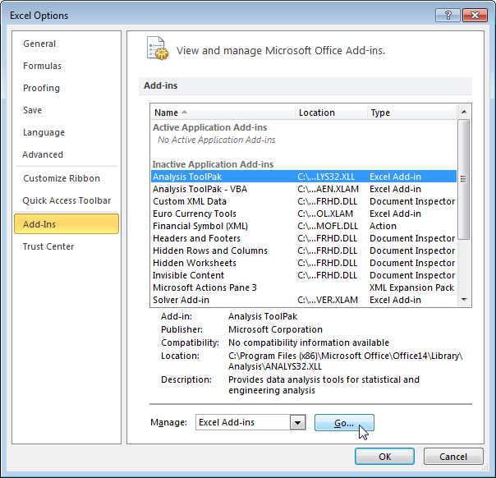

4. Check Analysis ToolPak and click on OK.

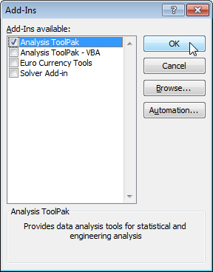

5. On the Data tab, you can now click on **Data Analysis**.

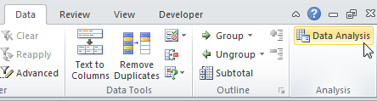

The following dialog box below appears.

6. For example, select Histogram and click OK to create a Histogram in Excel.

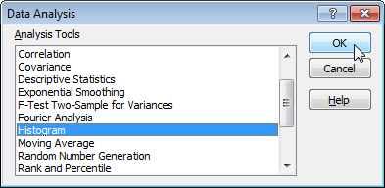

**Histogram**

This example teaches you how to create a **histogram** in **Excel**.

1. First, enter the bin numbers (upper levels) in the range C3:C7.

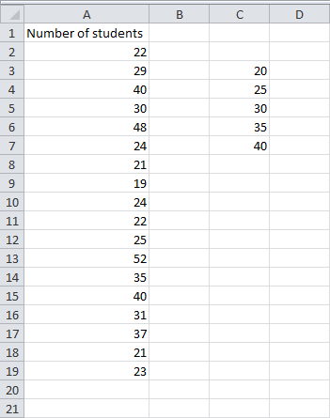

2. On the Data tab, click **Data Analysis**.



Note: can't find the Data Analysis button? Click here to load the Analysis ToolPak add-in.

3. Select Histogram and click OK.



4. Select the range A2:A19.

5. Click in the Bin Range box and select the range C3:C7.

6. Click the Output Range option button, click in the Output Range box and select cell F3.

7. Check Chart Output.

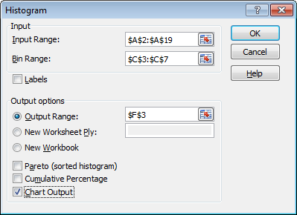

8. Click OK.

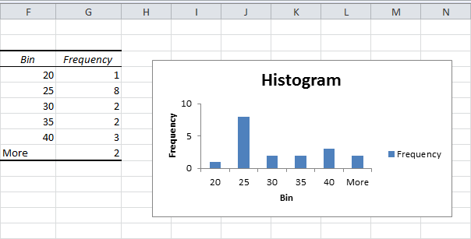

9. Click the legend on the right side and press Delete.

10. Properly label your bins.

11. To remove the space between the bars, right click a bar, select Format Data Series and change the Gap Width to 0%. Select Border Color to add a border.

Result:

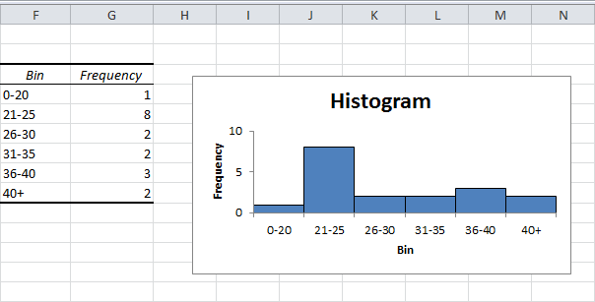

Do you like this free website? Please share this page on Google+

[2/10 Completed!](http://www.excel-easy.com/examples/descriptive-statistics.html)

**Descriptive Statistics**

You can use the Analysis Toolpak add-in to generate **descriptive statistics**. For example, you may have the scores of 14 participants for a test.

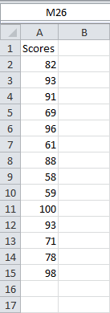

To generate descriptive statistics for these scores, execute the following steps.

1. On the Data tab, click **Data Analysis**.



Note: can't find the Data Analysis button? Click here to load the Analysis ToolPak add-in.

2. Select Descriptive Statistics and click OK.

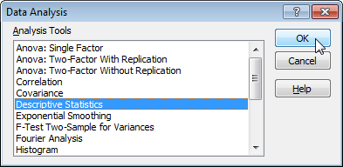

3. Select the range A2:A15 as the Input Range.

4. Select cell C1 as the Output Range.

5. Make sure Summary statistics is checked.

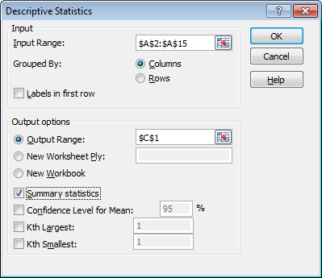

6. Click OK.

Result:

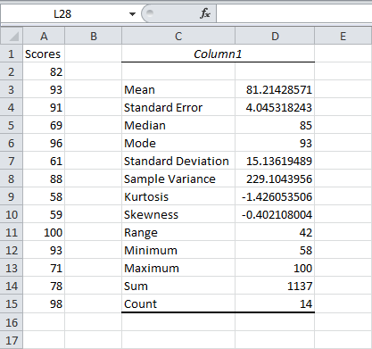

Do you like this free website? Please share this page on Google+

[3/10](http://www.excel-easy.com/examples/anova.html)

**Anova**

This example teaches you how to perform a single factor **ANOVA** (analysis of variance) in **Excel**. A single factor or one-way ANOVA is used to test the null hypothesis that the means of several populations are all equal.

Below you can find the salaries of people who have a degree in economics, medicine or history.

H0: μ1 = μ2 = μ3  
H1: at least one of the means is different.

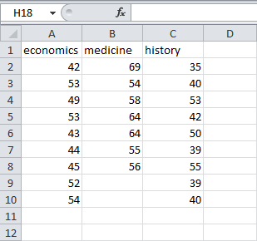

To perform a single factor **ANOVA**, execute the following steps.

1. On the Data tab, click Data Analysis.



Note: can't find the Data Analysis button? Click here to load the Analysis ToolPak add-in.

2. Select Anova: Single Factor and click OK.

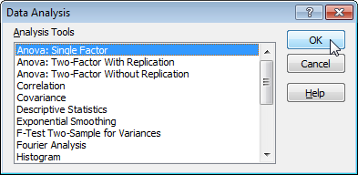

3. Click in the Input Range box and select the range A2:C10.

4. Click in the Output Range box and select cell E1.

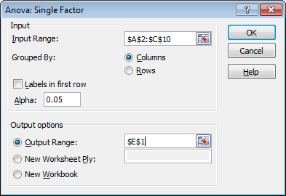

5. Click OK.

Result:

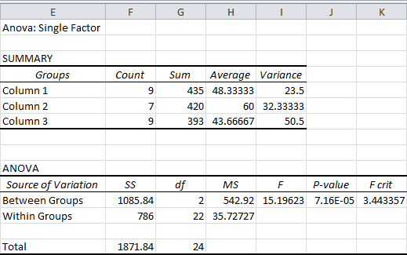

Conclusion: if F > F crit, we reject the null hypothesis. This is the case, 15.196 > 3.443. Therefore, we reject the null hypothesis. The means of the three populations are not all equal. At least one of the means is different. However, the **ANOVA** does not tell you where the difference lies. You need a t-Test to test each pair of means.

4/10 Completed!

**F-Test**

This example teaches you how to perform an **F-Test** in **Excel**. The F-Test is used to test the null hypothesis that the variances of two populations are equal.

Below you can find the study hours of 6 female students and 5 male students.

H0: σ12 = σ22  
H1: σ12 ≠ σ22

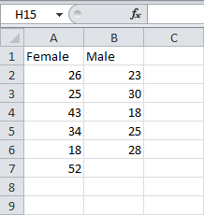

To perform an F-Test, execute the following steps.

1. On the Data tab, click Data Analysis.



Note: can't find the Data Analysis button? Click here to load the Analysis ToolPak add-in.

2. Select F-Test Two-Sample for Variances and click OK.

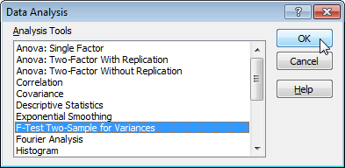

3. Click in the Variable 1 Range box and select the range A2:A7.

4. Click in the Variable 2 Range box and select the range B2:B6.

5. Click in the Output Range box and select cell E1.

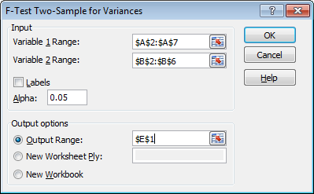

6. Click OK.

Result:

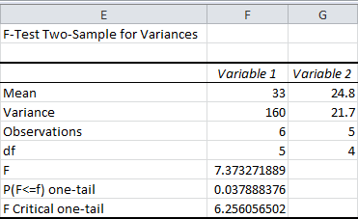

Important: be sure that the variance of Variable 1 is higher than the variance of Variable 2. This is the case, 160 > 21.7. If not, swap your data. As a result, Excel calculates the correct F value, which is the ratio of Variance 1 to Variance 2 (F = 160 / 21.7 = 7.373).

Conclusion: if F > F Critical one-tail, we reject the null hypothesis. This is the case, 7.373 > 6.256. Therefore, we reject the null hypothesis. The variances of the two populations are unequal.

Do you like this free website? Please share this page on Google+

5/10 Completed!

**t-Test**

This example teaches you how to perform a **t-Test** in **Excel**. The t-Test is used to test the null hypothesis that the means of two populations are equal.

Below you can find the study hours of 6 female students and 5 male students.

H0: μ1 - μ2 = 0  
H1: μ1 - μ2 ≠ 0



To perform a t-Test, execute the following steps.

1. First, perform an F-Test to determine if the variances of the two populations are equal. This is not the case.

2. On the Data tab, click Data Analysis.



Note: can't find the Data Analysis button? Click here to load the Analysis ToolPak add-in.

3. Select t-Test: Two-Sample Assuming Unequal Variances and click OK.

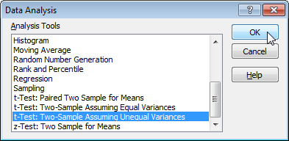

4. Click in the Variable 1 Range box and select the range A2:A7.

5. Click in the Variable 2 Range box and select the range B2:B6.

6. Click in the Hypothesized Mean Difference box and type 0 (H0: μ1 - μ2 = 0).

7. Click in the Output Range box and select cell E1.

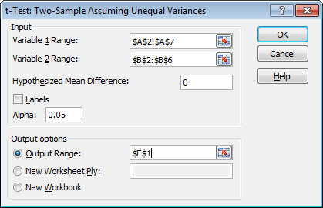

8. Click OK.

Result:

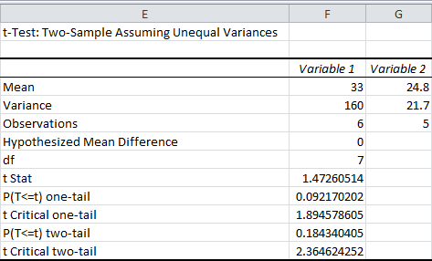

Conclusion: We do a two-tail test (inequality). lf t Stat < -t Critical two-tail or t Stat > t Critical two-tail, we reject the null hypothesis. This is not the case, -2.365 < 1.473 < 2.365. Therefore, we do not reject the null hypothesis. The observed difference between the sample means (33 - 24.8) is not convincing enough to say that the average number of study hours between female and male students differ significantly.

Do you like this free website? Please share this page on Google+

6/10 Completed!

**Moving Average**

A moving average is a technique to get an overall idea of the trends in a data set; it is an average of any subset of numbers. The moving average is extremely useful for **forecasting long –term trend.** You can calculate it for any period of time. For example, if you have sales data for a twenty- year periods, you can calculate a five- year moving average, a four –year moving average, a three-year moving average and so on. Stock market analysis will often use a 50 or 200 day moving average to help them see trends in the stock Market and (hopefully) forecast where the stocks are headed.

An average represents the “middling” value of a set of numbers. This moving average is exactly the same, **but the average is calculated several subsets of data**. For example, if you want a two – year moving average for a data set from 2000, 2001, 2002, 2003 you would find averages for the subsets 2000/2001, 2001/2002 and 2002/2003. Moving averages are usually plotted and are best visualized.

This example teaches you how to calculate the **moving average** of a time series in **Excel**. A moving average is used to smooth out irregularities (peaks and valleys) to easily recognize trends.

1. First, let's take a look at our time series.

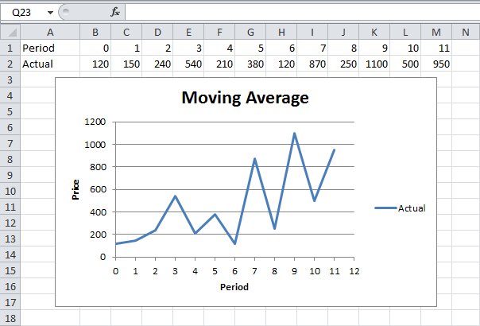

2. On the Data tab, click Data Analysis.



Note: can't find the Data Analysis button? Click here to load the Analysis ToolPak add-in.

3. Select Moving Average and click OK.

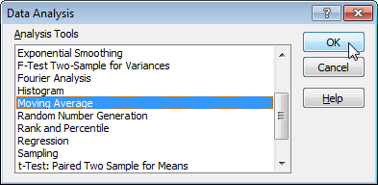

4. Click in the Input Range box and select the range B2:M2.

5. Click in the Interval box and type 6.

6. Click in the Output Range box and select cell B3.

7. Click OK.

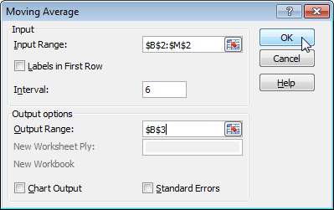

8. Plot a graph of these values.

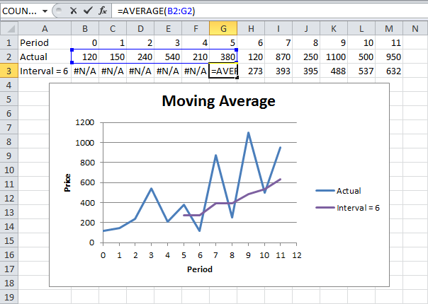

Explanation: because we set the interval to 6, the moving average is the average of the previous 5 data points and the current data point. As a result, peaks and valleys are smoothed out. The graph shows an increasing trend. Excel cannot calculate the moving average for the first 5 data points because there are not enough previous data points.

9. Repeat steps 2 to 8 for interval = 2 and interval = 4.

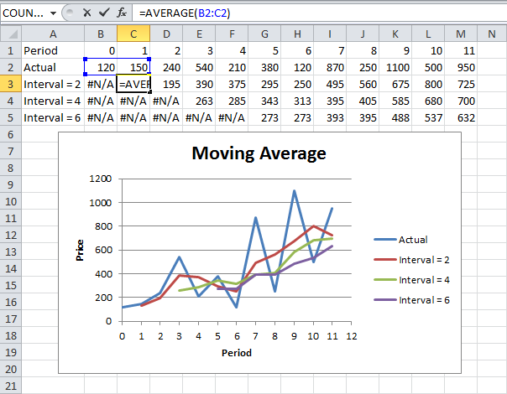

Conclusion: The larger the interval, the more the peaks and valleys are smoothed out. The smaller the interval, the closer the moving averages are to the actual data points.

CALCULATING A 5 YEAR MOVING AVERAGE EXAMPLE

**Sample problem:** Calculate a five –year moving average from the following data set:

|  |  |
| --- | --- |
| **Year** | **Sales ($M)** |
| 2003 | 4 |
| 2004 | 6 |
| 2005 | 5 |
| 2006 | 8 |
| 2007 | 9 |
| 2008 | 5 |
| 2009 | 4 |
| 2010 | 3 |
| 2011 | 7 |
| 2012 | 8 |

The mean (average) sales for the first five years (2003-2007) is calculated by finding the mean from the mean from the first five years (i.e. adding the five sales total and dividing by 5). This gives you the moving average for 2005 (the center year) =6.4M

|  |  |
| --- | --- |
| **Year** | **Sales ($M)** |
| 2003 | 4 |
| 2004 | 6 |
| 2005 | 5 |
| 2006 | 8 |
| 2007 | 9 |

(4M+6M+5M+8M+9M)/5=6.4M

The average sale for the **second subset of five years (2004-2008),** centered around 2006, is 6.6M: (6M+5M+8M+9M+5M)/5=6.6M

The average sale for the third **subset of five years (2005-2009)**, centered around 2007, is 6.6M:

(5M+8M+9M+5M+4M)/5=6.2M

Continue calculating each five –year average, until you reach the end of the set (2009-2013). This gives you a series of points (averages) that you can use to plot a chart of moving averages. The following Excel table shows you the moving averages calculated for 2003-2012 along with a scatter plot of the data.

|  |  |  |
| --- | --- | --- |
| Year | Sales ($M) | Moving average. |
| 2003 | 4 |  |
| 2004 | 6 |  |
| 2005 | 5 | 6.4 |
| 2006 | 8 | 6.6 |
| 2007 | 9 | 6.2 |
| 2008 | 5 | 5.8 |
| 2009 | 4 | 5.6 |
| 2010 | 3 | 5.4 |
| 2011 | 7 |  |
| 2012 | 8 |  |

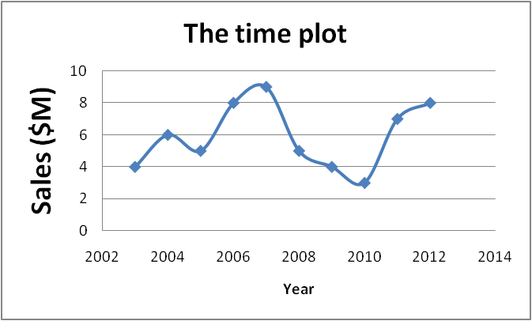

**This time plot is plotted on excel using scatter chart with Year and Sales ($M) on the table.**

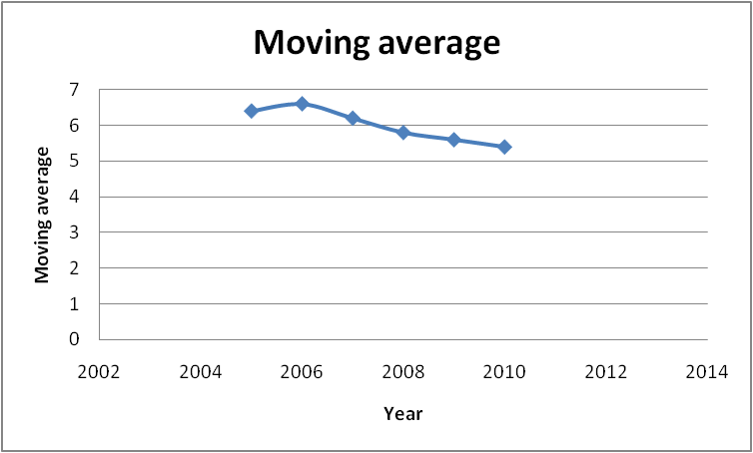

**This moving average plot is plotted on excel using scatter chart with Year and moving average on the table.**

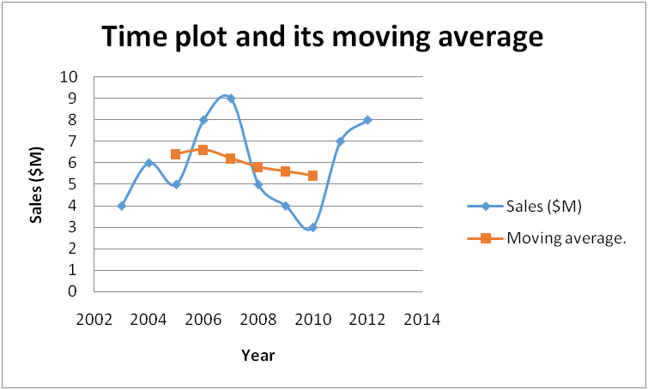

**This time plot and moving average is plotted on excel using scatter chart with Year, Sales ($M) and moving average on the table (Use the appropriate chart layouts).**

7/10 Completed!

**Exponential Smoothing**

This example teaches you how to apply **exponential smoothing** to a time series in **Excel**. Exponential smoothing is used to smooth out irregularities (peaks and valleys) to easily recognize trends.

1. First, let's take a look at our time series.

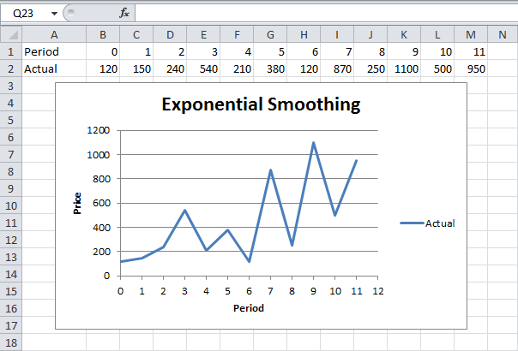

2. On the Data tab, click Data Analysis.



Note: can't find the Data Analysis button? Click here to load the Analysis ToolPak add-in.

3. Select Exponential Smoothing and click OK.

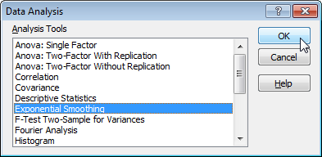

4. Click in the Input Range box and select the range B2:M2.

5. Click in the Damping factor box and type 0.9. Literature often talks about the smoothing constant α (alpha). The value (1- α) is called the damping factor.

6. Click in the Output Range box and select cell B3.

7. Click OK.

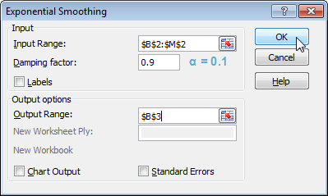

8. Plot a graph of these values.

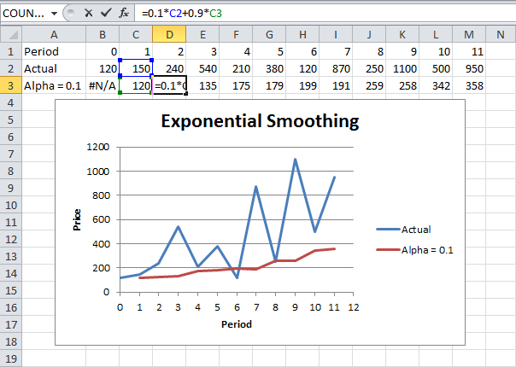

Explanation: because we set alpha to 0.1, the previous data point is given a relatively small weight while the previous smoothed value is given a large weight (i.e. 0.9). As a result, peaks and valleys are smoothed out. The graph shows an increasing trend. Excel cannot calculate the smoothed value for the first data point because there is no previous data point. The smoothed value for the second data point equals the previous data point.

9. Repeat steps 2 to 8 for alpha = 0.3 and alpha = 0.8.

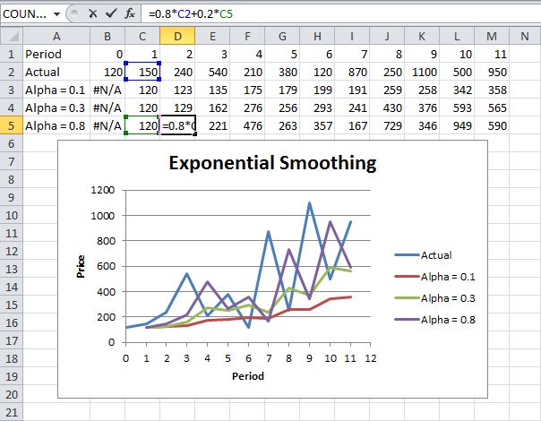

Conclusion: The smaller alpha (larger the damping factor), the more the peaks and valleys are smoothed out. The larger alpha (smaller the damping factor), the closer the smoothed values are to the actual data points.

Do you like this free website? Please share this page on Google+

8/10 Completed!

**Correlation**

The **correlation** coefficient (a value between -1 and +1) tells you how strongly two variables are related to each other. We can use the **CORREL function** or the **Analysis Toolpak add-in** in **Excel** to find the correlation coefficient between two variables.

- A correlation coefficient of +1 indicates a perfect positive correlation. As variable X increases, variable Y increases. As variable X decreases, variable Y decreases.

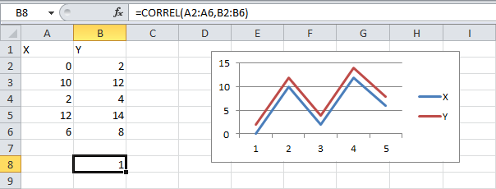

- A correlation coefficient of -1 indicates a perfect negative correlation. As variable X increases, variable Z decreases. As variable X decreases, variable Z increases.

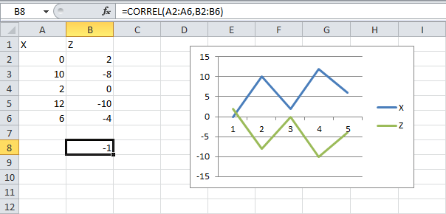

- A correlation coefficient near 0 indicates no correlation.

To use the Analysis Toolpak add-in in Excel to quickly generate correlation coefficients between multiple variables, execute the following steps.

1. On the Data tab, click Data Analysis.



Note: can't find the Data Analysis button? Click here to load the Analysis ToolPak add-in.

2. Select Correlation and click OK.

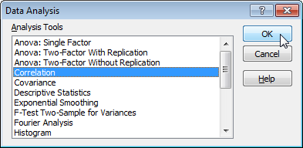

3. For example, select the range A1:C6 as the Input Range.

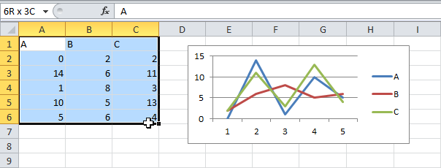

4. Check Labels in first row.

5. Select cell A9 as the Output Range.

6. Click OK.

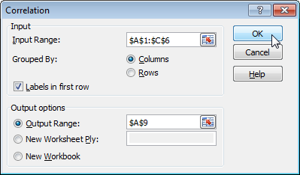

Result.

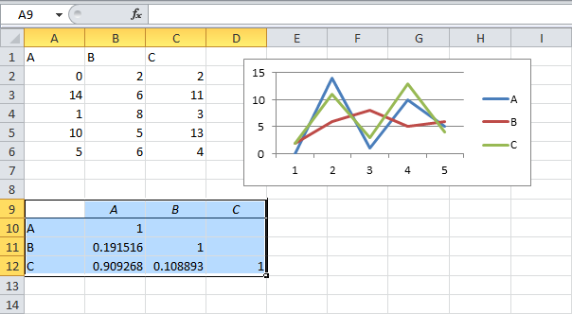

Conclusion: variables A and C are positively correlated (0.91). Variables A and B are not correlated (0.19). Variables B and C are also not correlated (0.11) . You can verify these conclusions by looking at the graph.

Do you like this free website? Please share this page on Google+

9/10 Completed!

# Regression

R Square | Significance F and P-Values | Coefficients | Residuals

This example teaches you how to perform a **regression** analysis in **Excel** and how to interpret the Summary Output.

Below you can find our data. The big question is: is there a relation between Quantity Sold (Output) and Price and Advertising (Input). In other words: can we predict Quantity Sold if we know Price and Advertising?

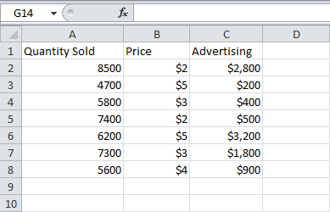

1. On the Data tab, click Data Analysis.



Note: can't find the Data Analysis button? Click here to load the Analysis ToolPak add-in.

2. Select Regression and click OK.

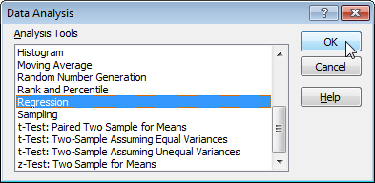

3. Select the Y Range (A1:A8). This is the predictor variable (also called dependent variable).

4. Select the XRange(B1:C8). These are the explanatory variables (also called independent variables). These columns must be adjacent to each other.

5. Check Labels.

6. Select an Output Range.

7. Check Residuals.

8. Click OK.

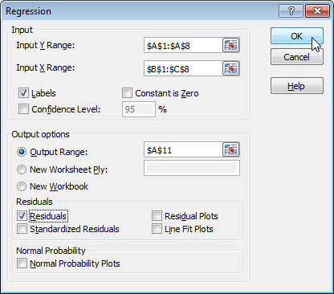

Excel produces the following Summary Output (rounded to 3 decimal places).

### R Square

R Square equals 0.962, which is a very good fit. 96% of the variation in Quantity Sold is explained by the independent variables Price and Advertising. The closer to 1, the better the regression line (read on) fits the data.

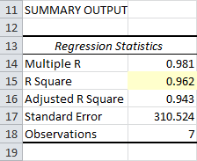

### Significance F and P-values

To check if your results are reliable (statistically significant), look at Significance F (0.001). If this value is less than 0.05, you're OK. If Significance F is greater than 0.05, it's probably better to stop using this set of independent variables. Delete a variable with a high P-value (greater than 0.05) and rerun the regression until Significance F drops below 0.05.

Most or all P-values should be below below 0.05. In our example this is the case. (0.000, 0.001 and 0.005).

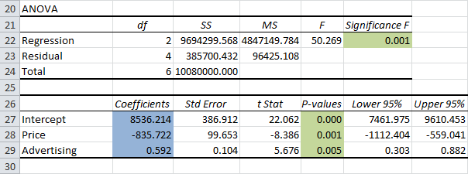

### Coefficients

The regression line is: y = Quantity Sold = 8536.214-835.722 * Price + 0.592 * Advertising. In other words, for each unit increase in price, Quantity Sold decreases with 835.722 units. For each unit increase in Advertising, Quantity Sold increases with 0.592 units. This is valuable information.

You can also use these coefficients to do a forecast. For example, if price equals $4 and Advertising equals $3000, you might be able to achieve a Quantity Sold of 8536.214 -835.722 * 4 + 0.592 * 3000 = 6970.

### Residuals

The residuals show you how far away the actual data points are from the predicted data points (using the equation). For example, the first data point equals 8500. Using the equation, the predicted data point equals 8536.214 -835.722 * 2 + 0.592 * 2800 = 8523.009, giving a residual of 8500 - 8523.009 = -23.009.

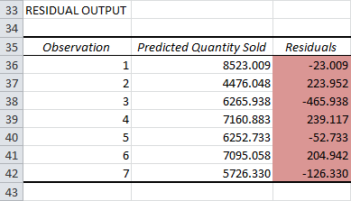

You can also create a scatter plot of these residuals.

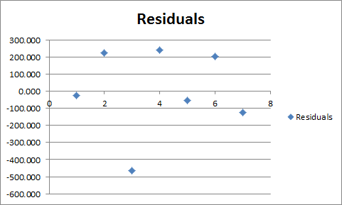

[10/10 Completed!](http://www.excel-easy.com/data-analysis/analysis-toolpak.html)